- Difference Between Ethernet Cables and Fiber Optic Cables
1. Transmission Medium
- Ethernet cable uses copper wires to send electrical signals (small electric pulses that carry data).
- Fiber optic cable uses thin glass or plastic fibers to send light signals (flashes of light that carry data).
2. Speed and Distance
- Ethernet cable is best for short distances (up to 100 meters) and is commonly used in homes and offices.
- Fiber optic cable can send data at very high speed over long distances (many kilometers) without losing signal quality.
3. Interference
- Ethernet cable can be affected by electromagnetic interference (EMI) (disturbance caused by electrical devices like motors or heavy machines).
- Fiber optic cable is not affected by EMI because it uses light instead of electricity.
- Real-World Examples
  - Ethernet Cable
Example: Connecting a home WiFi router to a desktop computer or gaming PC for a stable internet connection.
  - Fiber Optic Cable
Example: Connecting different buildings in a college campus backbone (the main network that connects all buildings together) or connecting servers in a data center (a building that stores many computers and servers).

- Internal Wiring of a Straight-Through Ethernet Cable (T568B Standard)

- Introduction:
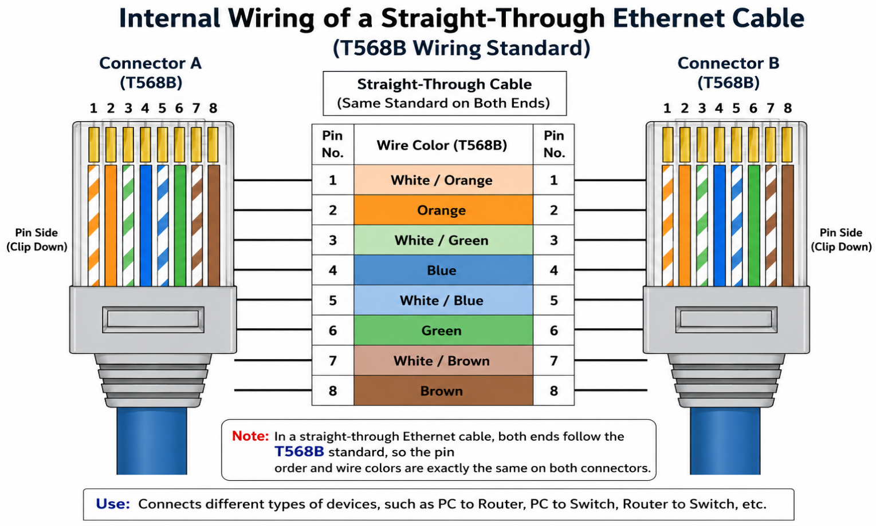
A straight-through Ethernet cable is a network cable used to connect different networking devices, such as a computer to a router or a computer to a switch (a device that connects multiple computers in a network). In the T568B standard (the standard color order for Ethernet cables), both ends of the cable have the same wire sequence.

- Explanation:

- The Ethernet cable contains 8 wires.
- Each wire is connected to a specific pin number.
- In the T568B standard, both connectors have the same wire color order.
- Because both ends are wired the same, it is called a straight-through cable.

- Uses:
- Connecting a computer to a router.
- Connecting a computer to a switch.
- Connecting a router to a switch.

- Conclusion:
A straight-through Ethernet cable using the T568B wiring standard is one of the most commonly used network cables. It provides a reliable connection between different networking devices.

- Step-by-Step Guide to Attach an RJ45 Connector to a CAT6 Cable

- Introduction:
An RJ45 connector (the plastic connector used at the end of an Ethernet cable) is attached to a CAT6 cable (a network cable used for high-speed internet and networking) using an RJ45 crimping tool (a tool that fixes the connector onto the cable). The steps below are based on the standard crimping process shown in networking tutorials.

- Step-by-Step Procedure:

- Step 1: Gather the Required Tools
Collect the following items:
- CAT6 cable
- RJ45 connector
- RJ45 crimping tool
- Wire stripper (or the stripper on the crimping tool)
- Cable tester (optional, but recommended)

- Step 2: Strip the Outer Jacket
Use the wire stripper to remove about 2–3 cm of the outer cover of the CAT6 cable. Be careful not to damage the wires inside.
- Step 3: Untwist the Wire Pairs
Separate the 4 twisted pairs (8 individual wires) and straighten them with your fingers.
- Step 4: Arrange the Wires (T568B Standard)
Arrange the wires in this order:
- White/Orange
- Orange
- White/Green
- Blue
- White/Blue
- Green
- White/Brown
- Brown
- Step 5: Trim the Wires
Hold the wires tightly together and cut them evenly so that all the wires are the same length.
- Step 6: Insert the Wires into the RJ45 Connector
Carefully slide the wires into the RJ45 connector. Make sure each wire reaches the end of the connector and stays in the correct order.
- Step 7: Crimp the Connector
Insert the RJ45 connector into the crimping tool and squeeze the handles firmly. This locks the connector onto the cable and makes electrical contact with the wires.
- Step 8: Test the Cable
Use a cable tester (a device that checks whether all 8 wires are connected correctly) to make sure the cable is working properly.

- Conclusion:
By following these steps, an RJ45 connector can be correctly attached to a CAT6 cable. A properly crimped cable provides a reliable network connection and reduces the chances of communication errors.

- Setting Up a Gaming Café with 10 PCs for LAN Gaming

For a gaming café with 10 PCs, I would use Ethernet (CAT6) cables because the computers are in the same room, so fiber optic cables are not needed. Ethernet cables provide high speed, low delay (latency - the time taken for data to travel between devices), and they are less expensive, making them a better choice for the budget. I would use an RJ45 crimper to attach RJ45 connectors to the Ethernet cables. This setup is reliable, easy to install, and is commonly used for LAN (Local Area Network) gaming.

